Electronic Regulatory Binder

REDCap Administrator (Super User) Instructions

Contents

Document Description 1

To create the eRegulatory Binder REDCap project: 2

To add the Custom Reports (PlugIns): 2

To make the project a Project Template: 2

# Document Description

The Electronic Regulatory Binder (eReg binder) is a project within REDCap (http://project-redcap.org/) that was developed by Partners Human Research Quality Improvement (QI) Program and Enterprise Research Infrastructure & Services (ERIS). Poster presentation at REDCapCon 2015:

**A Solution to Creating and Managing your Regulatory Binder Electronically**

*Partners Human Research Quality Improvement (QI) Program: Michele Gomez, CIP, Stephen Hayes, Charlene Malarick, RN, Emily Ouellette, JD, Angela Savlidis, Sarah White, MPH, CIP; Partners Research Computing, Enterprise Research Infrastructure & Services (ERIS): Jeremy Alphonse, Dimitar Dimitrov, MSSE, Lynn Simpson, MPH*

The eReg binder assists sites with the electronic storage and maintenance of regulatory documents for IRB approved protocols.

The project consists of

* A REDCap project (created as a template) (see Data Dictionary folder)
* A Protocol Version/Amendment Tracking Log plugin (va_tracking.php)
* Consent Form tracking plugin – (eb_consent_report.php)
* Delegation Log plugin – (create_eb_report.php)

To access the REDCap software and view participating institutions and administrators:

<http://project-redcap.org/>.

For project and system requirements, please see the eReg Binder Plugins Manual available on GitHub: <https://github.com/phseris>

# To create the eRegulatory Binder REDCap project:

A Super User or a Project User can create the base (no PlugIns) eREG Binder project in their institution’s REDCap instance.

1. Access GitHub to download the Electronic Regulatory Binder Data Dictionary and Manual: <https://github.com/PHSERIS/eReg-Binder>
2. Using your REDCap account:
   1. Create a new project
   2. Import the Data Dictionary

# To add the Custom Reports (PlugIns):

An admin with access to the webserver directories can add the plugin files. The REDCap plugins are located within the “plugins” folder of the REDCap installations. In Linux, this is typically /var/www/html/redcap/plugins.

1. Once the project is created, please refer to the “eReg Binder Plugins Manual” located in GitHub to add the plugins to the project.

NOTE: To ensure the plugins work correctly, project users should be told not to update certain variable names within their project. If they do, the plugin will require updates to reference the new variable names. Within the Data Dictionary, “Field Annotations” have been included to designate which variables are referenced by the reports.

# To make the project a Project Template:

1. On Project Home, click “Add” for “Project is not used as a template” to add the project as a template. Provide a name and description for the template.

With the Project Template now added, when users request a project be created, the template will be listed at the bottom of the page:

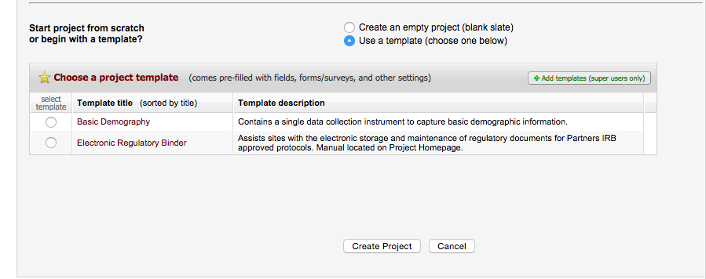

1. If desired, a message can be displayed at the top of the Project Home page to let the users know whom to contact with questions concerning the template and provide a link to the User Manual.

To add:

* 1. Go to the Control Center and navigate to “Project Settings” for the project that is being used as a template.
  2. Modify the “Custom text to display at top of Project Home page in project” field as needed.
  3. The message will then appear at the top of your Project Home page in green. In this text is where we included an project-user manual (created by our QI group):

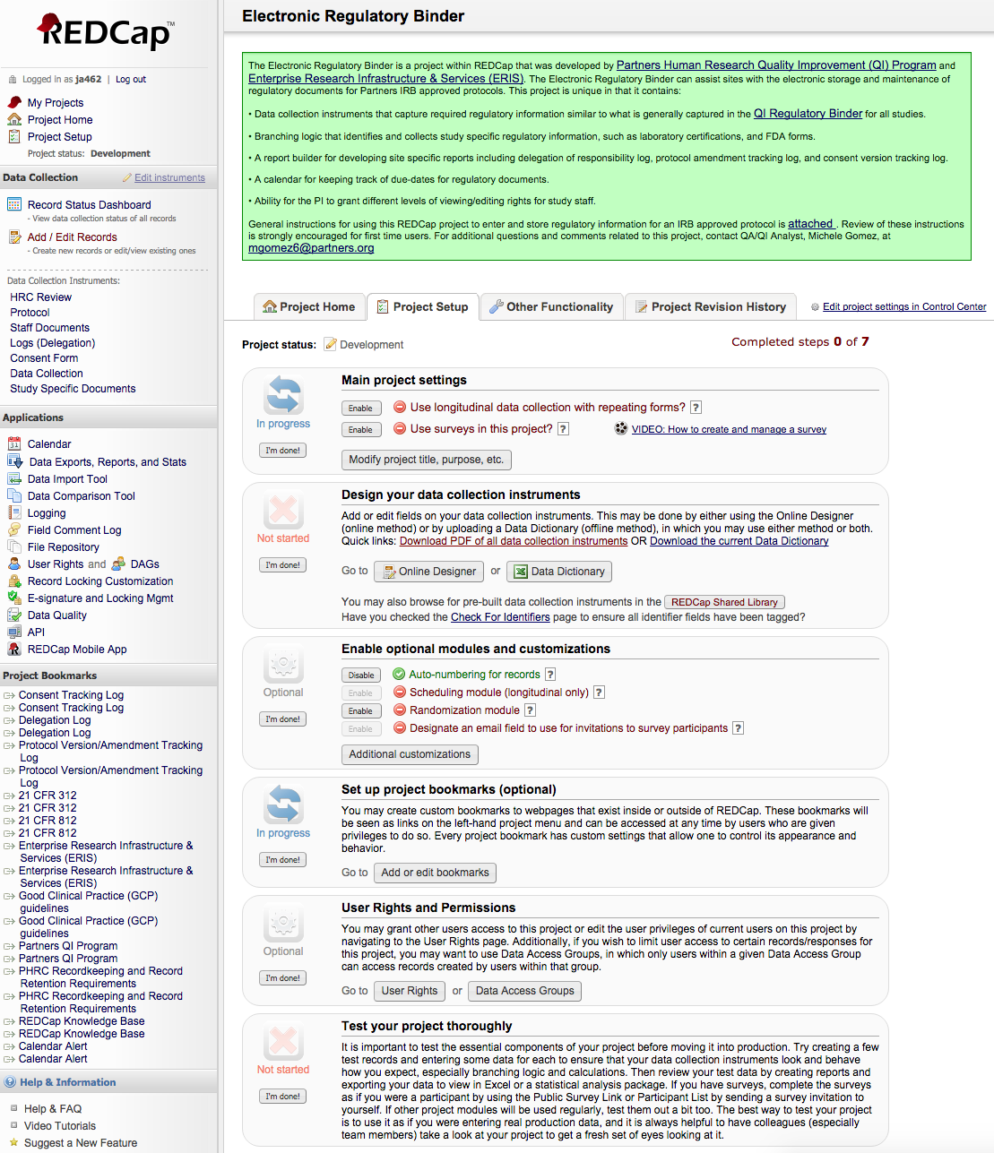

Please see note in eReg Binder Plugins Manual about optional custom code to ensure the custom text and plugIns are included for each new project created from the template.